ASSIGNEMT COVA PAGE .

PAGE:1



**Faculty of Engineering, Built Environment, and Information Technology**

|  |
| --- |
| **Course Details:**  Module Code and Title : **TCS3024 / TNS3033 Introductory Programming**  Program of Study : **Bachelor of Information Technology (Hons)**  **Bachelor of Computer Science (Hons) in Cybersecurity**  Lecturer’s Name : **Ms. Noor Hafizah Ismail**  Semester : **SEPT – DEC 2022**  **Assessment Details:**  Title of Assessment : **Introductory Programming Assignment**  Submission Date : **Friday, 25th November 2022 @ 6.00pm**  **Declaration by student:**  *I hereby declare that the attached assignment is my/our own work and understand that if I am suspected of plagiarism or another form of cheating, my/our work will be referred to the Program Coordinator/Head of Faculty who may, as a result recommend to the Examinations Board on academic disciplinary action including expulsion from SEGi University and Colleges.*  **Student’s Details:**  **Name: Mohamed Sano**  **Student ID: SUKD2102014 Signature ____________**  **Overall Marks:**  /20  **Reminder:**   1. Students are reminded to keep a copy of all the coursework submitted. 2. All LATE SUBMISSION will be DEDUCTED 5% a day up to a maximum of TEN (10) days, where subsequently, the coursework will be awarded ZERO (0). |

TABLE OF CONTENTS.

PAGE:2

1. PAGE:1 (COVER PAGE).
2. PAGE:2 (TABLE OF CONTENTS).
3. PAGE:3 (FLOWCHART).
4. PAGE:4 (SOURCE CODE).
5. PAGE:5 (SOURCE CODE).
6. PAGE:6 (TESTING OF THE PROGRAM).

Design of the program (Flowchart).

PAGE:3

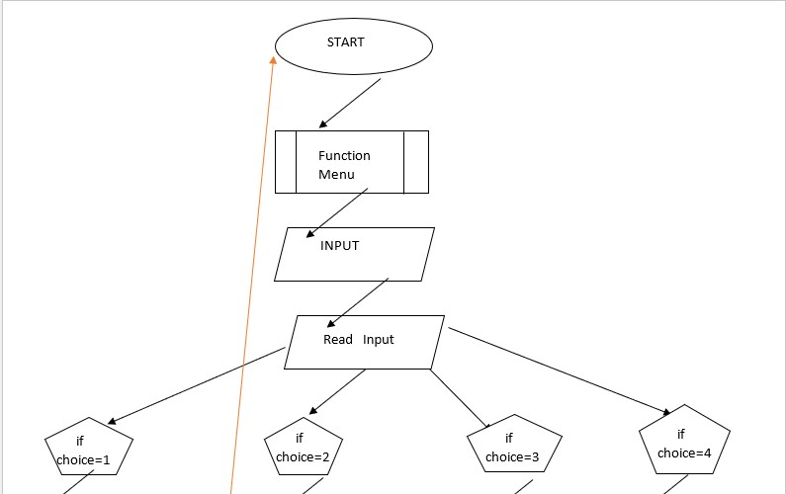

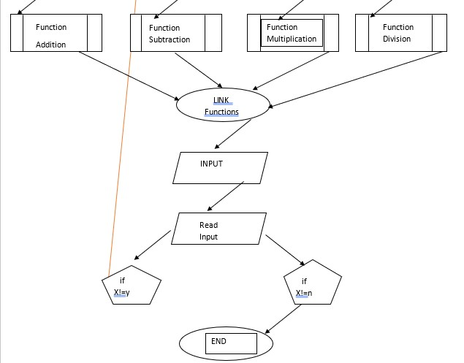

Source code of the program in C++.

PAGE:4

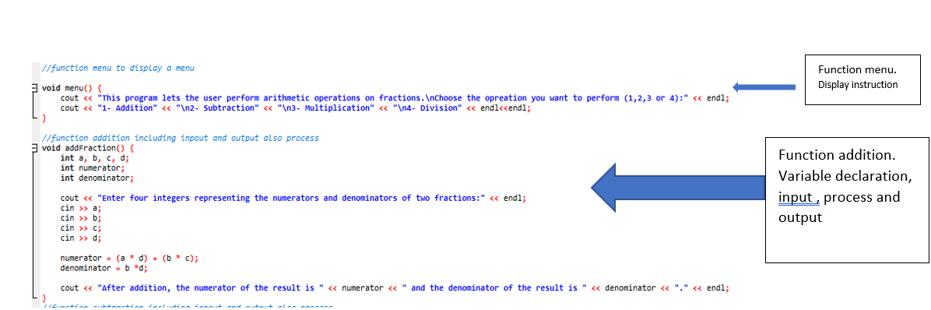

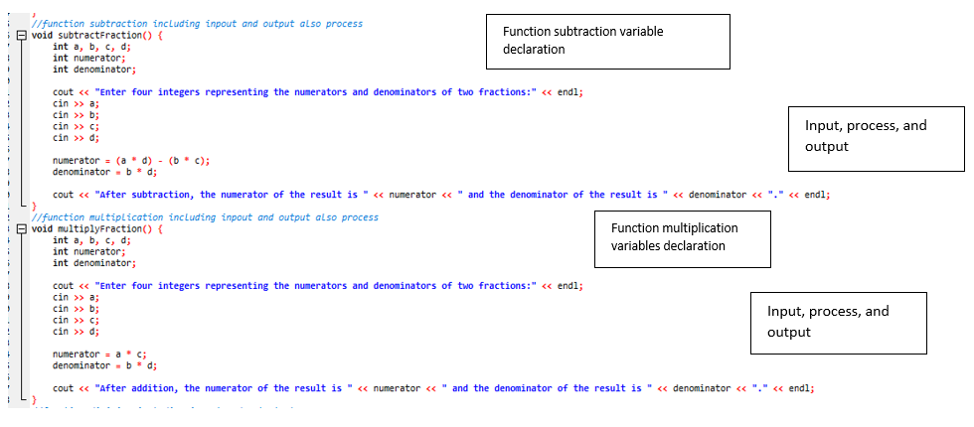

PAGE:5

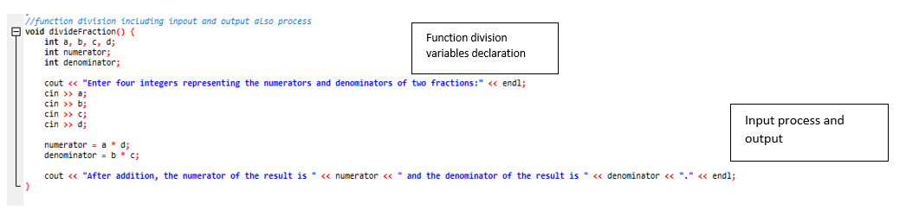

TESTING PROGRAM.

PAGE:6



